Archimedean Spiral
# Source: AI Source: Provided by: [Data Path: Persons Table -> ID Column: 1, Name_En Column: Motasem Essam] -> From: [ChatGPT] on [7/25/2026]
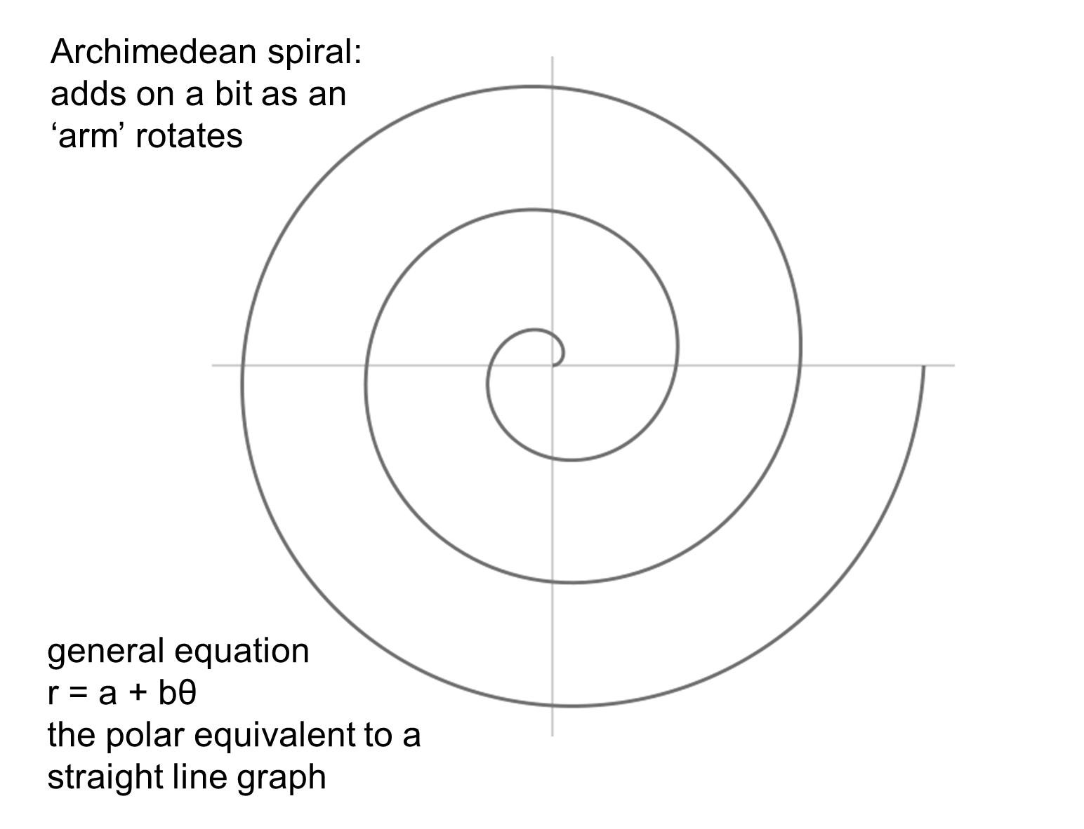
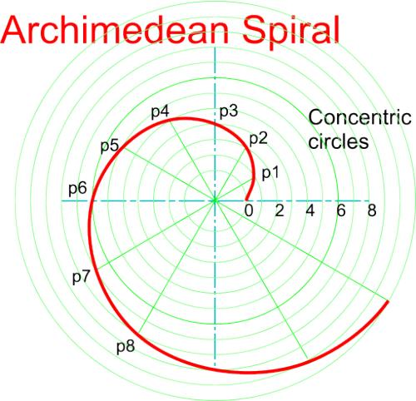
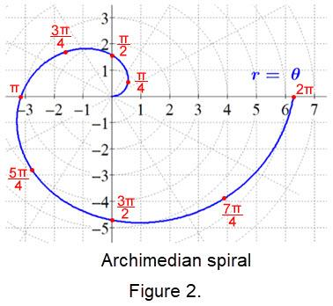
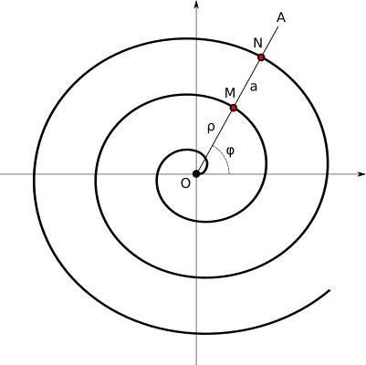
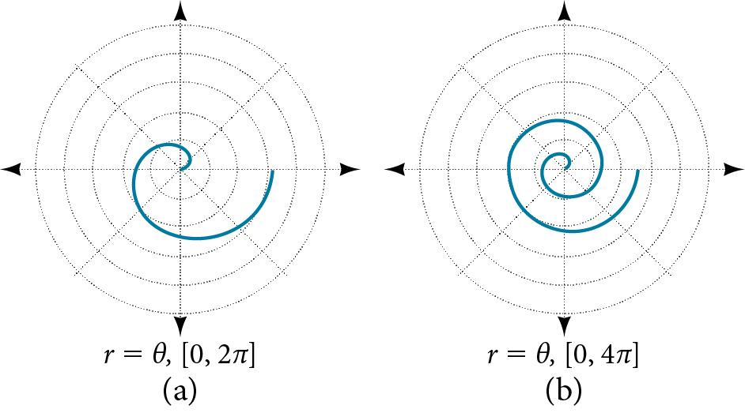
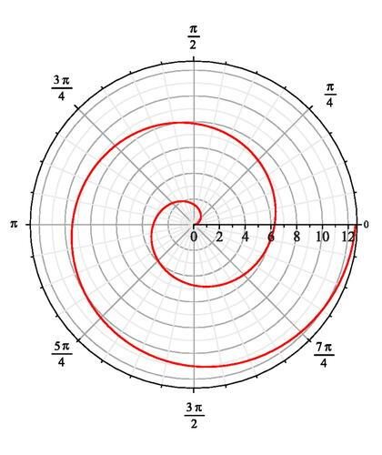

Definition
# Source: AI Source: Provided by: [Data Path: Persons Table -> ID Column: 1, Name_En Column: Motasem Essam] -> From: [ChatGPT] on [7/25/2026]
An Archimedean Spiral is a spiral in which the distance from the center changes linearly with the angle.
Its standard polar equation is:
$$\boxed{r=a+bθ}$$
where:
- $r$= radial distance from the pole
- $θ$= angle measured from a reference direction
- $a$= initial radial distance
- $b$= rate at which the radius changes with angle
The defining property is:
$$\boxed{\frac{dr}{dθ}=b=\text{constant}}$$

Fundamental Concept
# Source: AI Source: Provided by: [Data Path: Persons Table -> ID Column: 1, Name_En Column: Motasem Essam] -> From: [ChatGPT] on [7/25/2026]
As the spiral rotates through equal angular intervals, its radius changes by equal amounts.
For example, if
$$r=a+bθ$$
then increasing $θ$by $2π$changes the radius by:
$$Δr=b\left(2π\right)$$
Therefore:
$$\boxed{Δr=2πb}$$
This means that successive turns of an Archimedean Spiral have constant radial spacing.

Basic Structure
# Source: AI Source: Provided by: [Data Path: Persons Table -> ID Column: 1, Name_En Column: Motasem Essam] -> From: [ChatGPT] on [7/25/2026]
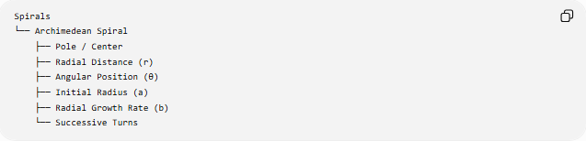
Spirals
└── Archimedean Spiral
├── Pole / Center
├── Radial Distance (r)
├── Angular Position (θ)
├── Initial Radius (a)
├── Radial Growth Rate (b)
└── Successive Turns
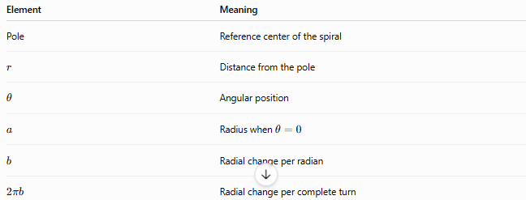
Element | Meaning
Pole | Reference center of the spiral
$$r$$ | Distance from the pole
$$θ$$ | Angular position
$$a$$ | Radius when $θ=0$
$$b$$ | Radial change per radian
$$2πb$$ | Radial change per complete turn

Mathematical Representation
# Source: AI Source: Provided by: [Data Path: Persons Table -> ID Column: 1, Name_En Column: Motasem Essam] -> From: [ChatGPT] on [7/25/2026]
Standard Polar Equation
$$\boxed{r=a+bθ}$$
Parametric Equations
Using
$$x=r\cos{θ}$$
and
$$y=r\sin{θ}$$
we obtain:
$$\boxed{x=\left(a+bθ\right)\cos{θ}} \\ \boxed{y=\left(a+bθ\right)\sin{θ}}$$
Radial Derivative
Differentiate:
$$r=a+bθ$$
with respect to $θ$:
$$\boxed{\frac{dr}{dθ}=b}$$
The radial rate is constant.

Meaning of the Constants
# Source: AI Source: Provided by: [Data Path: Persons Table -> ID Column: 1, Name_En Column: Motasem Essam] -> From: [ChatGPT] on [7/25/2026]
Constant $a$
At
$$θ=0$$
we have:
$$r=a$$
Therefore, $a$determines the starting radial distance.
Constant $b$
The parameter $b$determines how quickly the spiral moves outward or inward.
If:
$$b>0$$
the spiral expands outward as $θ$increases.
If:
$$b<0$$
the spiral contracts inward as $θ$increases.
If:
$$b=0$$
then:
$$r=a$$
which is simply a circle rather than a spiral.

Constant Spacing Between Turns
# Source: AI Source: Provided by: [Data Path: Persons Table -> ID Column: 1, Name_En Column: Motasem Essam] -> From: [ChatGPT] on [7/25/2026]
This is the defining geometric property of the Archimedean Spiral.
After one complete revolution:
$$θ→θ+2π$$
Therefore:
$$r\left(θ+2π\right)=a+b\left(θ+2π\right) \\ =a+bθ+2πb$$
Since
$$r\left(θ\right)=a+bθ$$
the radial difference is:
$$\boxed{r\left(θ+2π\right)-r\left(θ\right)=2πb}$$
Thus, every complete turn increases the radius by the same amount.

Number of Turns
# Source: AI Source: Provided by: [Data Path: Persons Table -> ID Column: 1, Name_En Column: Motasem Essam] -> From: [ChatGPT] on [7/25/2026]
For an angular interval $Δθ$, the number of complete turns is:
$$\boxed{N=\frac{Δθ}{2π}}$$
For $N$complete turns, the radial change is:
$$\boxed{Δr=2πbN}$$
For example, after $3$complete turns:
$$Δr=6πb$$

Direction of the Spiral
# Source: AI Source: Provided by: [Data Path: Persons Table -> ID Column: 1, Name_En Column: Motasem Essam] -> From: [ChatGPT] on [7/25/2026]
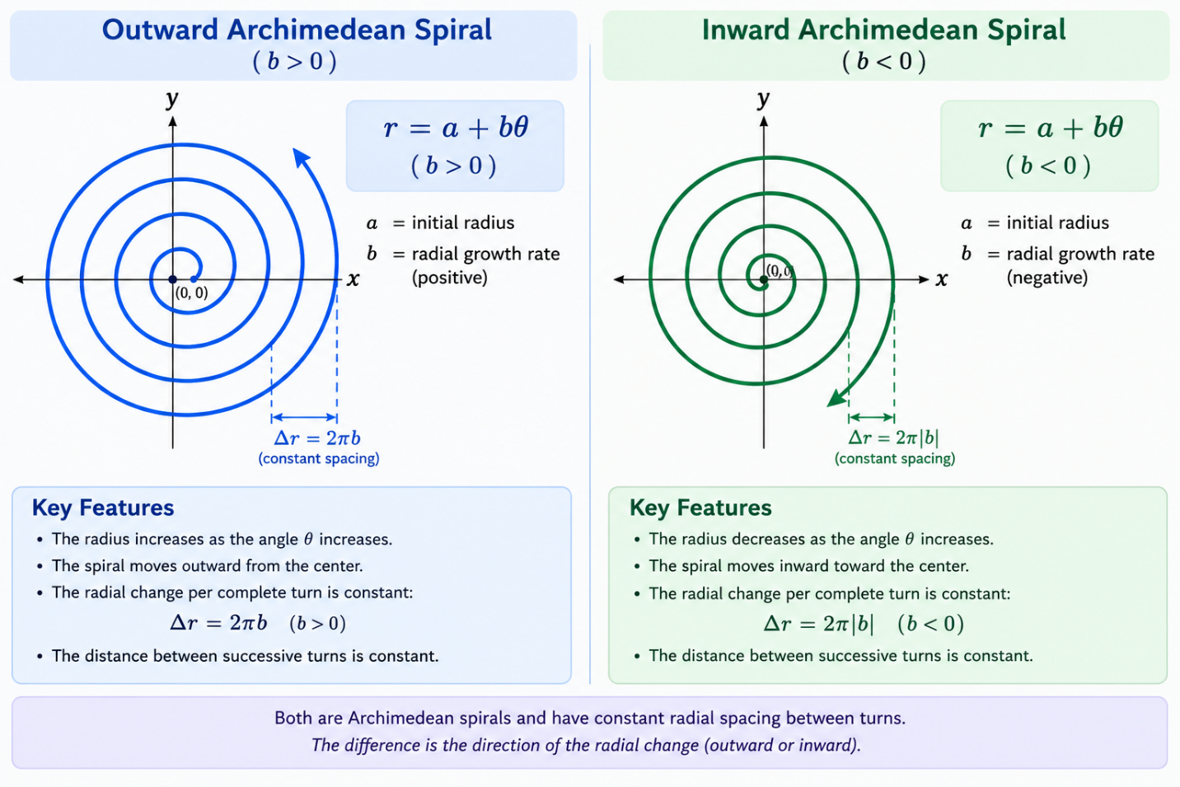

Outward Archimedean Spiral
# Source: AI Source: Provided by: [Data Path: Persons Table -> ID Column: 1, Name_En Column: Motasem Essam] -> From: [ChatGPT] on [7/25/2026]
If:
$$b>0$$
then:
$$\frac{dr}{dθ}>0$$
The radius increases as the spiral rotates.

Inward Archimedean Spiral
# Source: AI Source: Provided by: [Data Path: Persons Table -> ID Column: 1, Name_En Column: Motasem Essam] -> From: [ChatGPT] on [7/25/2026]
If:
$$b<0$$
then:
$$\frac{dr}{dθ}<0$$
The radius decreases as the spiral rotates.

Arc Length
# Source: AI Source: Provided by: [Data Path: Persons Table -> ID Column: 1, Name_En Column: Motasem Essam] -> From: [ChatGPT] on [7/25/2026]
For a polar curve $r=f\left(θ\right)$, the arc length is:
$$L=\int_{θ_{1}}^{θ_{2}}{\sqrt{r^{2}+{\left(\frac{dr}{dθ}\right)}^{2}}} dθ$$
For an Archimedean Spiral:
$$r=a+bθ$$
and
$$\frac{dr}{dθ}=b$$
Therefore:
$$\boxed{L=\int_{θ_{1}}^{θ_{2}}{\sqrt{{\left(a+bθ\right)}^{2}+b^{2}}} dθ}$$

Area Swept by the Spiral
# Source: AI Source: Provided by: [Data Path: Persons Table -> ID Column: 1, Name_En Column: Motasem Essam] -> From: [ChatGPT] on [7/25/2026]
The area between two radial positions of a polar curve is:
$$A=\frac{1}{2}\int_{θ_{1}}^{θ_{2}}{r^{2}} dθ$$
For the Archimedean Spiral:
$$\boxed{A=\frac{1}{2}\int_{θ_{1}}^{θ_{2}}{(}\left.a+bθ{\left.)\right.}^{2} dθ\right.}$$
After integration:
$$\boxed{A=\frac{{\left(a+bθ_{2}\right)}^{3}-{\left(a+bθ_{1}\right)}^{3}}{6b}}$$
for $b≠0$.

Example
# Source: AI Source: Provided by: [Data Path: Persons Table -> ID Column: 1, Name_En Column: Motasem Essam] -> From: [ChatGPT] on [7/25/2026]
Consider:
$$\boxed{r=2+θ}$$
Here:
$$a=2, b=1$$
At $θ=0$
$$r=2$$
After one complete turn
$$θ=2π \\ r=2+2π$$
Therefore, the radial increase is:
$$Δr=\left(2+2π\right)-2 \\ \boxed{Δr=2π}$$
After two complete turns
$$θ=4π \\ r=2+4π$$
The radial increase from the starting point is:
$$\boxed{4π}$$

Archimedean Spiral vs Circle
# Source: AI Source: Provided by: [Data Path: Persons Table -> ID Column: 1, Name_En Column: Motasem Essam] -> From: [ChatGPT] on [7/25/2026]
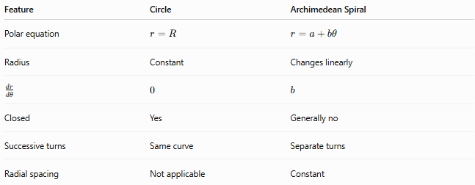
Feature | Circle | Archimedean Spiral
Polar equation | $$r=R$$ | $$r=a+bθ$$
Radius | Constant | Changes linearly
$$\frac{dr}{dθ}$$ | $$0$$ | $$b$$
Closed | Yes | Generally no
Successive turns | Same curve | Separate turns
Radial spacing | Not applicable | Constant
The fundamental difference is:
$$\boxed{\text{Circle: }r=\text{constant}} \\ \boxed{\text{Archimedean Spiral: }r=a+bθ}$$

Archimedean Spiral vs Logarithmic Spiral
# Source: AI Source: Provided by: [Data Path: Persons Table -> ID Column: 1, Name_En Column: Motasem Essam] -> From: [ChatGPT] on [7/25/2026]
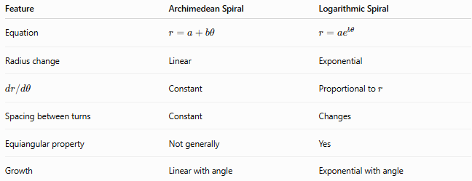
Feature | Archimedean Spiral | Logarithmic Spiral
Equation | $$r=a+bθ$$ | $$r=ae^{bθ}$$
Radius change | Linear | Exponential
$$dr/dθ$$ | Constant | Proportional to $r$
Spacing between turns | Constant | Changes
Equiangular property | Not generally | Yes
Growth | Linear with angle | Exponential with angle
Thus:
$$\boxed{\text{Archimedean: linear radial growth}} \\ \boxed{\text{Logarithmic: exponential radial growth}}$$

Geometric Characteristics
# Source: AI Source: Provided by: [Data Path: Persons Table -> ID Column: 1, Name_En Column: Motasem Essam] -> From: [ChatGPT] on [7/25/2026]
An Archimedean Spiral:
- winds continuously around a pole;
- generally forms multiple turns;
- has continuously changing radial distance;
- has a constant radial change per unit angle;
- has constant radial spacing between successive turns;
- can expand outward or contract inward;
- is generally an open curve;
- can be represented naturally using polar coordinates.

Classification
# Source: AI Source: Provided by: [Data Path: Persons Table -> ID Column: 1, Name_En Column: Motasem Essam] -> From: [ChatGPT] on [7/25/2026]
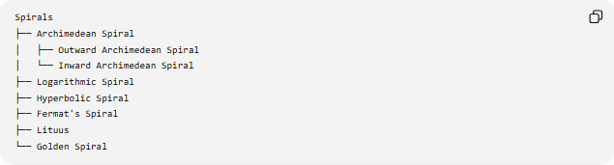
Spirals
├── Archimedean Spiral
│ ├── Outward Archimedean Spiral
│ └── Inward Archimedean Spiral
├── Logarithmic Spiral
├── Hyperbolic Spiral
├── Fermat's Spiral
├── Lituus
└── Golden Spiral
Outward and inward Archimedean Spiral are descriptive classifications based on the sign of $b$, rather than separate fundamental mathematical families.

Key Points
# Source: AI Source: Provided by: [Data Path: Persons Table -> ID Column: 1, Name_En Column: Motasem Essam] -> From: [ChatGPT] on [7/25/2026]
- An Archimedean Spiral has the polar equation:
$$\boxed{r=a+bθ}$$
- Its radius changes linearly with the angle.
- Its radial derivative is constant:
$$\boxed{\frac{dr}{dθ}=b}$$
- The radial change during one complete turn is:
$$\boxed{Δr=2πb}$$
- Therefore, successive turns have constant radial spacing.
- $b>0$produces outward radial growth.
- $b<0$produces inward radial growth.
- $b=0$reduces the equation to a circle.
- Its arc length is:
$$\boxed{L=\int_{θ_{1}}^{θ_{2}}{\sqrt{{\left(a+bθ\right)}^{2}+b^{2}}} dθ}$$
- Its swept area is:
$$\boxed{A=\frac{1}{2}\int_{θ_{1}}^{θ_{2}}{(}\left.a+bθ{\left.)\right.}^{2} dθ\right.}$$

Conclusion
# Source: AI Source: Provided by: [Data Path: Persons Table -> ID Column: 1, Name_En Column: Motasem Essam] -> From: [ChatGPT] on [7/25/2026]
The Archimedean Spiral is a fundamental type of spiral defined by the linear relationship
$$\boxed{r=a+bθ}$$
between radial distance and angular position. Its most important characteristic is its constant radial spacing between successive turns. Each additional revolution changes the radius by the same amount,
$$\boxed{2πb}$$
which distinguishes it from spirals such as the logarithmic spiral, whose radial growth is exponential.

